
College of Computer Studies

DATA STRUCTURES AND ALGORITHMS
(CCS0015L)

SCHOOL ORGANIZATION EVENT MANAGER

GRADE

Submitted by:

1X1
PICTURE

1X1
PICTURE

1X1
PICTURE

1X1
PICTURE

[Student name] | [Course and section]
Submitted to: [Professor's name]
Date of Defense: [Date]

- Introduction
School organizations often announce several events, each with a date, place, leader, attendance limit, and age rule. A manual list makes it difficult to tell who is registered and whether spaces remain. School Organization Event Manager is a Java console application that gives event managers and attendees separate accounts and menus. It organizes event details and derives attendance counts from active registrations.
The program was selected because the two roles and their relationships can be modeled clearly with classes, inheritance, encapsulation, and an interface. It is a learning prototype: records remain in memory for one run, and it has no database, email service, or payment feature.
- Description of the Project
An event manager can create an account, log in, create an event, edit an event they own, cancel an event, view their events, and inspect registrants. An attendee can create an account, log in, browse event details, register, cancel a registration, and view active registrations. Event details include title, description, start date and time, location, leader, minimum age, capacity, status, and active count.
Registration is rejected when the event is canceled or has started, the attendee is too young on the event date, the attendee already has an active registration, or the event is full. An attendee account uses Lastname,Firstname. The event title is added only to each registration label, allowing one account to join multiple events.
- Objectives
- Develop a working Java console application with distinct manager and attendee menus and accounts.
- Store and validate event details and prevent unauthorized manager changes.
- Apply age, duplicate, capacity, status, and start-time registration rules.
- Calculate event attendance from active registration records.
- Demonstrate object-oriented design with encapsulation, inheritance, overriding, polymorphism, abstraction, and an interface.
- Document and test normal, invalid, empty, repeated, and boundary input cases.
- Significance of the Study
Event managers benefit from a consistent list of event details and registrants. Attendees can see eligibility information before registration and manage their own participation. For the course, the project shows how a real school workflow can be divided into data classes, service classes, and a registration policy. The limitations are intentional: account passwords are demonstration data, information is not saved between runs, and the system is designed for a single local console user at a time.
- Project Details
The program contains 13 Java source files. Its services keep lists of accounts, events, and registrations in memory. The UML diagram below shows ownership, inheritance, and multiplicity.
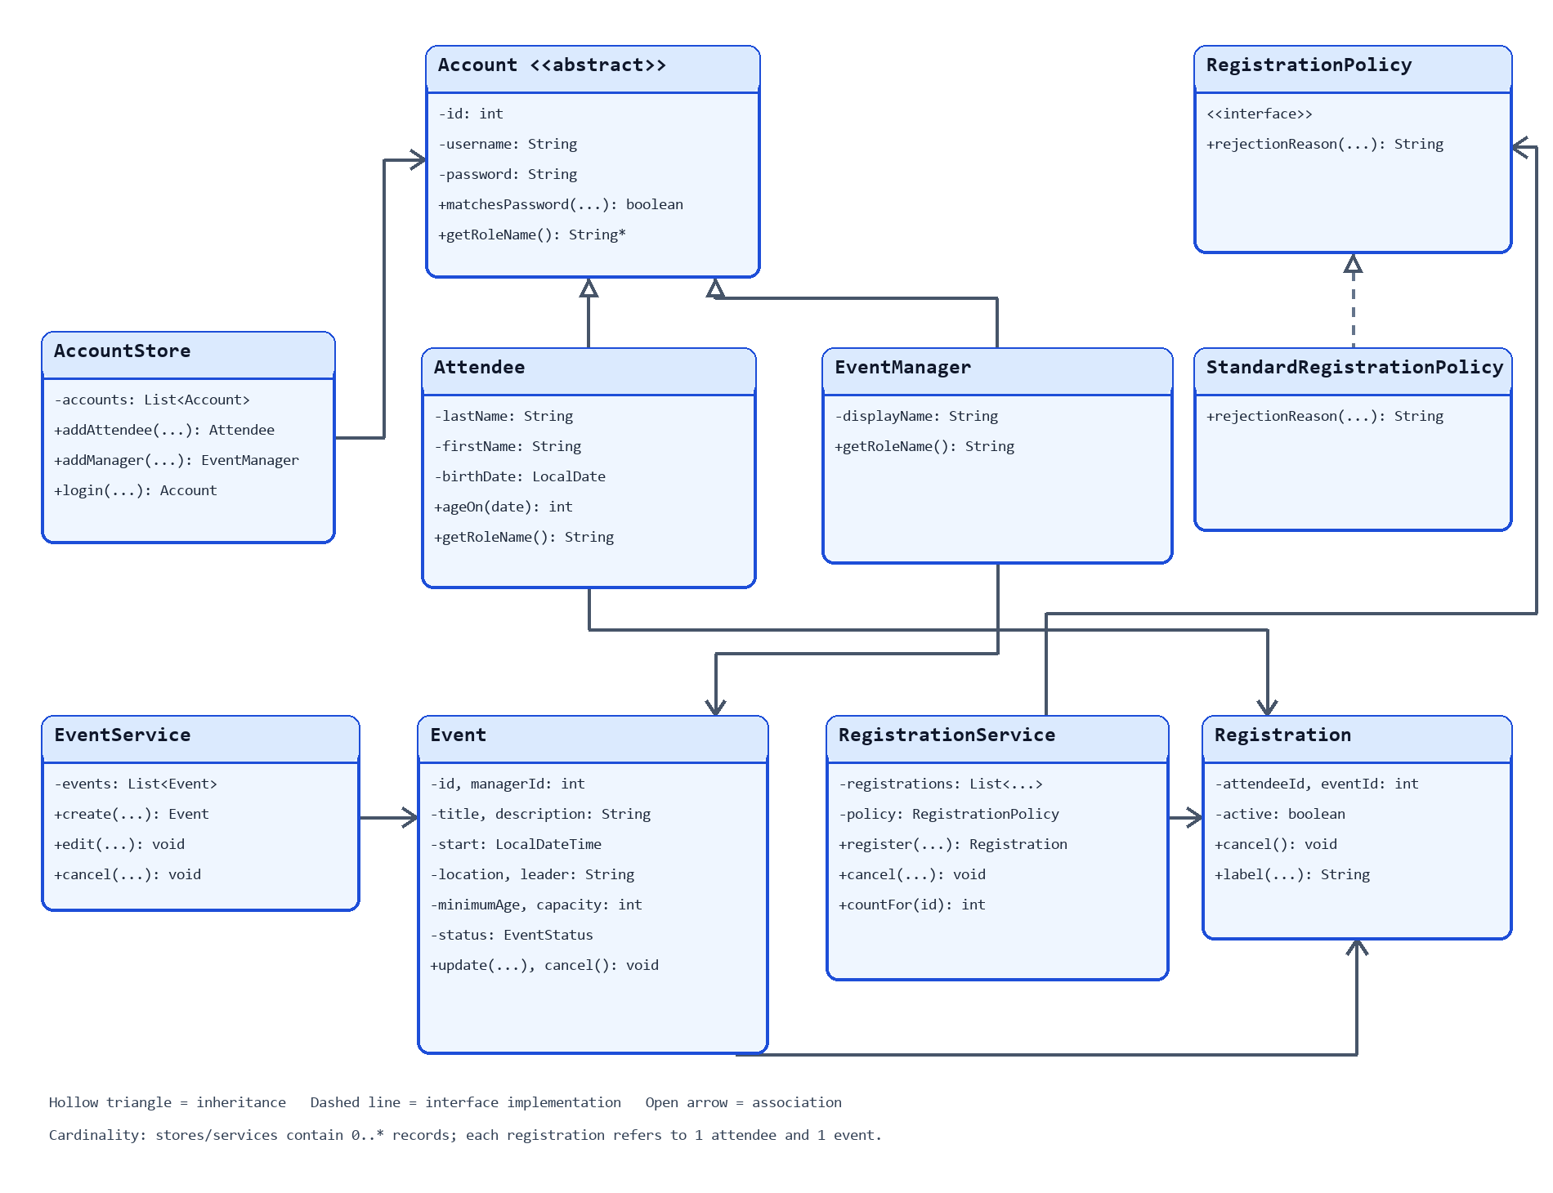
Figure 1. UML class diagram of the account, event, registration, service, and policy classes.
Table of Functions
Function | Scope | Purpose
Main.run and roleMenu | private | Repeat and route console menus
Main.required and readInt | private | Validate required text and integer ranges
AccountStore.login | public | Check credentials and role
EventService.create, edit, cancel | public | Maintain manager-owned events
RegistrationService.register, cancel | public | Change active registrations
RegistrationService.countFor | public | Count active registrations for an event
StandardRegistrationPolicy.rejectionReason | public | Apply registration eligibility rules

Table of Classes
Class or interface | Key access | Responsibility
Account; Attendee; EventManager | private fields; public methods | Shared login data and role-specific account behavior
Event | private fields; public methods | Event details, status, and validated updates
Registration | private fields; public methods | Link attendee and event; track active state
AccountStore; EventService | private lists; public methods | Manage accounts and manager-owned events
RegistrationService | private list and policy; public methods | Register, cancel, list, and count
RegistrationPolicy; StandardRegistrationPolicy | public interface method | Define and apply acceptance conditions
Main; SelfTest; EventStatus | mixed | Console control, verification, and status values

Table of Data Structures and ADT
Identifier | Structure and operations | Purpose
accounts | ArrayList<Account>; add, iterate, search | Hold attendee and manager accounts
events | ArrayList<Event>; add, iterate, search | Hold events and find manager-owned records
registrations | ArrayList<Registration>; add, iterate, filter | Track active participation and counts

Table of Algorithms
Algorithm | Location | Purpose
Age on event date | Attendee.ageOn; registration policy | Compare attendee age with each event's rule
Eligibility scan | StandardRegistrationPolicy | Reject duplicate entries and full events
Active count | RegistrationService.countFor | Derive displayed attendance from records
Input retry | Main.required; Main.readInt | Repeat prompts until a permitted value is entered

Division of Labor
Task | Responsible person | Status
Problem choice, final review, presentation, reflection | [Student name] | Complete personally before submission
Code assistance, explanations, test suggestions, document drafting | ChatGPT with student review | Assistance recorded in conversation

- Screen Output
The following captures show the manager and attendee flows, validation, and the NetBeans test run. The console images show captured program output; the NetBeans image shows the IDE result.
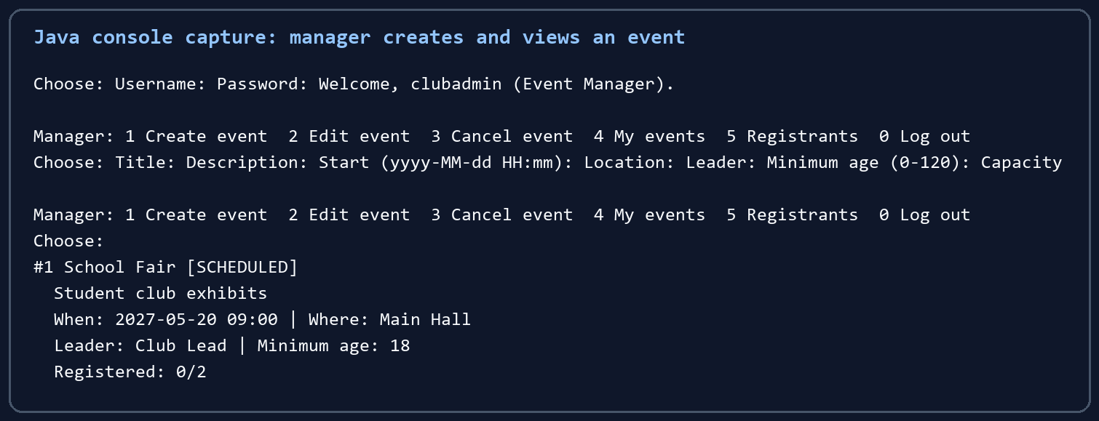
Figure 2. Manager creates and views School Fair with zero of two places filled.
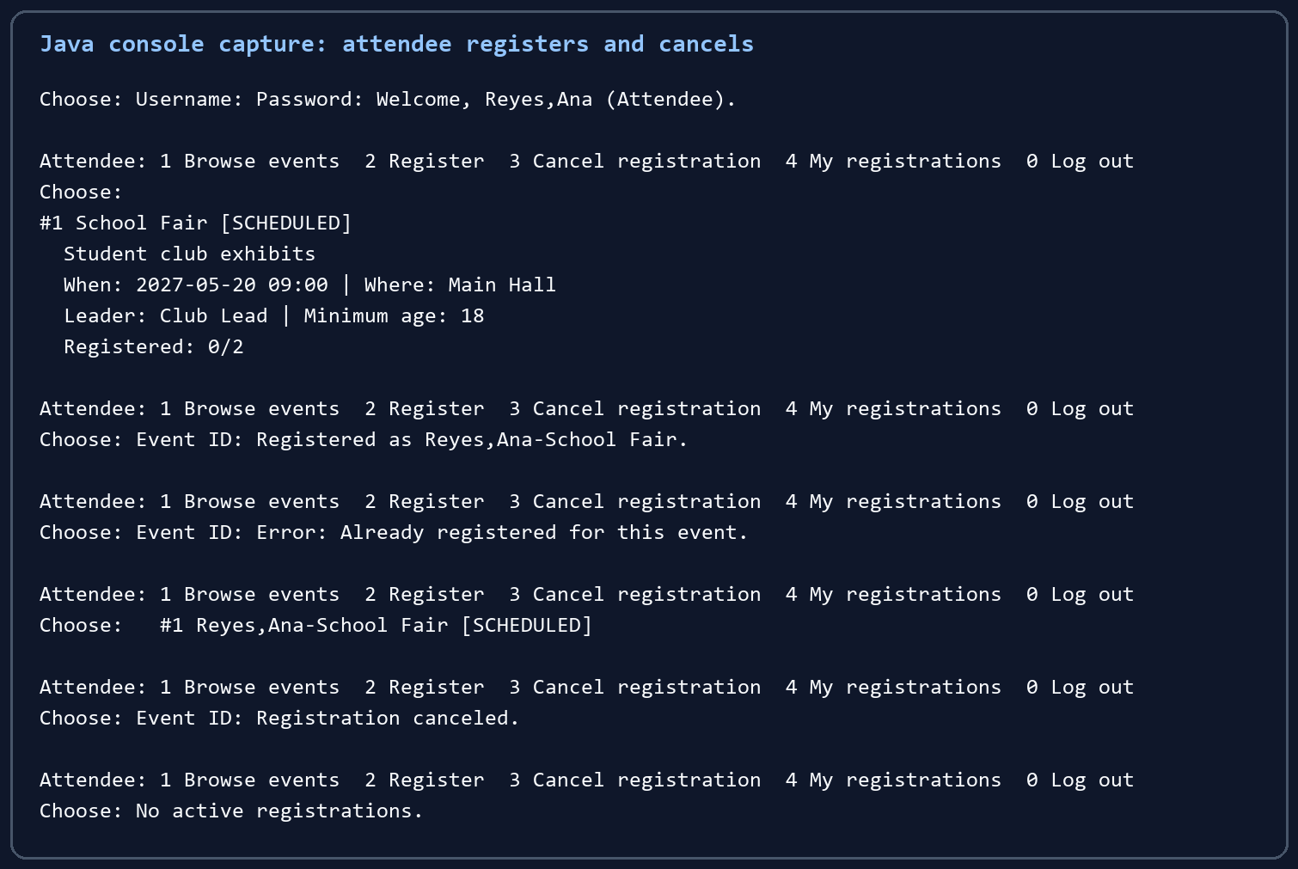
Figure 3. Attendee registers, receives a duplicate warning, and cancels the registration.
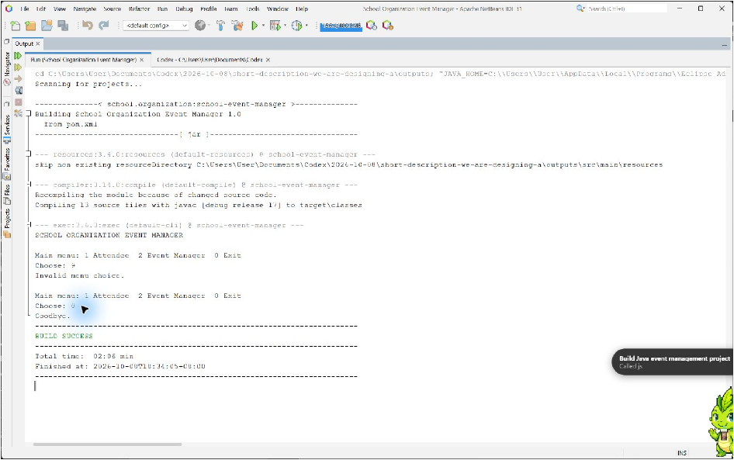
Figure 4. NetBeans console demonstrates invalid menu selection and required-field retry.
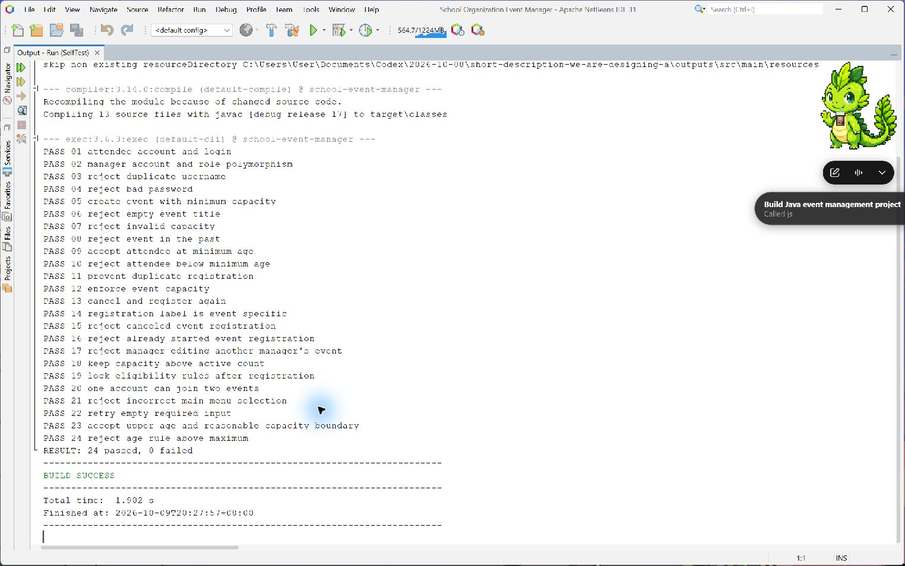
Figure 5. NetBeans displays 24 passing tests and a successful build.
- Test Cases
The 24 documented cases cover valid input, minimum and upper boundary values, invalid and empty input, an incorrect menu choice, repeated operations, both account subclasses, and alternate outcomes. The automated suite uses a fixed clock for repeatable date checks. The table records the expected and observed result of each case.
# | Feature | Input | Expected | Actual | Result
1 | Attendee account/login | Reyes; Ana; 2005-05-01; secret1 | Username and login succeed | Username and login succeeded | Pass
2 | Role polymorphism | Attendee and EventManager objects | Distinct role names via Account references | Attendee and Event Manager returned | Pass
3 | Duplicate username | reyes,ana after Reyes,Ana | Reject case-insensitive duplicate | Duplicate rejected | Pass
4 | Incorrect password | lead; wrong | Login fails | Login returned no account | Pass
5 | Minimum capacity | Age 0; capacity 1 | Event created with boundary values | Event created with boundary values | Pass
6 | Empty title | Whitespace title | Reject event | Event rejected | Pass
7 | Invalid capacity | Capacity 0 | Reject event | Event rejected | Pass
8 | Past event | 2025-01-01 09:00 with fixed 2026 clock | Reject past start | Past start rejected | Pass
9 | Minimum age boundary | Age exactly 18 on event day; minimum 18 | Accept registration | Registration accepted | Pass
10 | Below minimum age | Age 17 on event day; minimum 18 | Reject registration | Registration rejected | Pass
11 | Duplicate registration | Same attendee registers twice | Second attempt rejected and count stays 1 | Second attempt rejected and count stayed 1 | Pass
12 | Capacity reached | Capacity 1; second attendee | Reject second attendee | Second attendee rejected | Pass
13 | Cancel and repeat | Register; cancel; register again | Count changes 1 to 0 to 1 | Count changed 1 to 0 to 1 | Pass
14 | Registration label | Reyes Ana joins School Fair | Reyes,Ana-School Fair | Correct label returned | Pass
15 | Canceled event | Attempt registration after manager cancels | Reject registration | Registration rejected | Pass
16 | Started event | Attempt registration after start | Reject registration | Registration rejected | Pass
17 | Event ownership | Other manager edits event | Reject unauthorized edit | Edit rejected | Pass
18 | Capacity edit boundary | Two registrations then capacity 1 | Reject reduction | Reduction rejected | Pass
19 | Eligibility change after registration | Change event start and minimum age | Reject change | Change rejected | Pass
20 | Multiple events | One attendee joins two events | Two registrations under one account | Two registrations under one account | Pass
21 | Incorrect menu selection | 9 at main menu | Show invalid choice and continue | Invalid choice shown and main menu repeated | Pass
22 | Empty required input | Blank manager username then lead | Show error and retry username | Error shown and account created after retry | Pass
23 | Upper boundary | Minimum age 120; capacity 1000 | Accept valid upper and reasonable capacity values | Event created with both values | Pass
24 | Above maximum age rule | Minimum age 121 | Reject event | Event rejected | Pass

Observed automated result: 24 passed, 0 failed. The executable tests are in SelfTest.java; the full six-column test list is also supplied as test-cases.csv.
- Source Code
The complete source is supplied as 13 Java files in src/main/java/com/mycompany/event_organizer. The following excerpts identify the code blocks most relevant to input handling, policy decisions, and count accuracy.
Input validation in Main.java
// Repeats a required text prompt until the user enters content.
private String required(String string) {
String string2;
while ((string2 = this.read(string)).isBlank()) {
System.out.println("This field cannot be empty.");
}
return string2;
}
Eligibility policy in StandardRegistrationPolicy.java
// A started or canceled event cannot accept a new registration.
if (event.getStatus() == EventStatus.CANCELED) return "Event is canceled.";
if (!event.getStart().isAfter(localDateTime)) return "Event has already started.";
// Compare age on the event day, not on the day of sign-up.
if (attendee.ageOn(event.getStart().toLocalDate()) < event.getMinimumAge())
return "Attendee does not meet the event's minimum age.";
Active count in RegistrationService.java
// Count active records for this event; canceled records do not count.
public int countFor(int n) {
int n2 = 0;
for (Registration registration : this.registrations) {
if (!registration.isActive() || registration.getEventId() != n) continue;
++n2;
}
return n2;
}
Account is abstract; Attendee and EventManager extend it and override getRoleName(). RegistrationService depends on the RegistrationPolicy interface, implemented by StandardRegistrationPolicy. Private fields and validated methods control changes to accounts, events, and registrations.
- Conclusion
The Java console application supports event maintenance and attendee registration with separate roles. The test suite verified 24 normal, invalid, repeated, and boundary scenarios, and the NetBeans run reported 24 passed and 0 failed. The project demonstrates that choosing suitable classes and relationships makes event rules easier to explain and maintain. Its current limit is in-memory operation, so persistence and stronger authentication would be future improvements.
Before submission, the student should complete the name, course and section, professor, date, and personal presentation details on the cover; review the source and report; and provide the required video and complete ChatGPT conversation separately.

